ST. MARGARET MARY PARISH
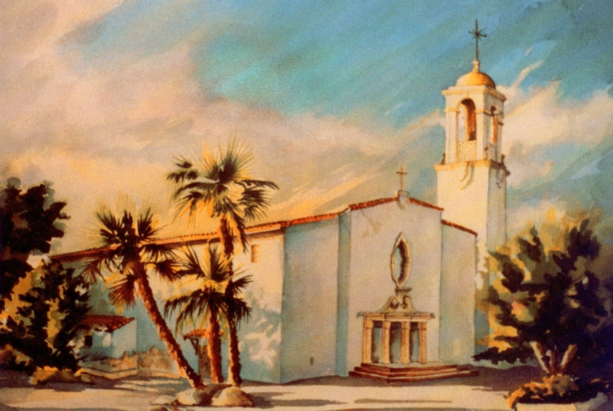
Preparing for Marriage
at
St. Margaret Mary Church
12686 Central Ave
Chino, California 91710
(909) 591-7400
Jesus performed his first miraculous sign at the wedding feast of Cana.
May He be a guest at your wedding and remain in your marriage always making you living signs and proofs of God’s existence and love!
WEDDING
Congratulations on your decision to marry! Through the centuries, our Roman Catholic Church has upheld the beauty and sanctity of married life. Your decision to marry is one of the most important of a lifetime of choices…and St. Margaret Mary Parish is pleased to assist you during this special time of preparation.
You will want to begin by meeting with one of the priests no later than 6 months before your wedding. The importance of sacramental marriage makes advance preparation both essential and enriching. In addition---if you are not already doing so, you are strongly encouraged to begin attending weekly Mass as a couple, as part of spiritual preparation for a whole new life.

PREPARATION
1. Contact the Parish Office (909-591-7400) to make an appointment with one of the priests to begin the process.
2. At your first meeting, the priest will help you fill out an information sheet, and the secretary will tell you how to take the PMI (Pre-Marital Inventory), a helpful internet tool that identifies areas of compatibility and contrast in your life as a couple.
3. Once you have completed the PMI (taken at home), you are invited to make a second appointment with the priest, to examine the results. At this time you will be able to calendar in your wedding date upon payment of the basic church offering. The priest will tell you about Engaged Encounter, a special weekend retreat (Friday evening to Sunday mid-afternoon), and show you how to make your reservation.
Please bring a recent copy of your baptismal certificate to this meeting.
4. After your engaged encounter, there is one more appointment with the priest, so he can tell you about support for your marriage preparation right here in our parish…and give you materials to help you plan your special wedding liturgy.
WEDDING DAY GUIDELINES
1. It is a very good idea for you and your wedding party to prepare spiritually for this special occasion by sacramental confession. Normal confession times at St. Margaret Mary are Saturday at 7:30 to 8:30 am…or almost anytime by appointment.
2. Arrangements for the wedding rehearsal are made with Ana Alcala (323) 209-7474 well in advance.
3. To plan music for your ceremony, please call Scott Hacker (909-529-2656) well in advance. The coordinator will let you know what is available, as well as guide you to music choices in keeping with liturgical guidelines.
MORE DETAILS!
• Only one professional photographer (No flash pictures are allowed except during the entrance procession and during the recession at the end of the ceremony). No passing in front or along the center aisle during the ceremony, please.
• One person videotaping inconspicuously. No special lights, no roll-around equipment. No passing in front of or along the center aisle during the ceremony, please.
• For good order, we ask that there be no aisle runners; no objects (e.g. rice, confetti, birdseed) thrown in or around the church; and no changing of the basic church environment.
This is a lot of “No’s”, but they are to make your celebration
respectful and reverent.

• We allow and encourage two (2) large bouquets of flowers, one at the altar and one at the ambo (pulpit). All flowers used in the sanctuary are left there as a thanksgiving offering to God.
• Marriage license must be delivered to the wedding coordinator at the rehearsal.
• Pew bows or flowers should be secured to the pews with rubber bands or covered floral wire only. No tape, please.
CUSTOMARY FEES
a) Church Offering - $350 covers the cost of rehearsal and ceremony (this is paid when you reserve your date with the church).
b) Musicians - $250 for cantor and accompanist (this is due before the wedding).
c) Wedding Coordinator - $150 (this is due the night of the rehearsal).
d) Engaged Encounter (Offering is set by the Engaged Encounter Movement).
e) You are welcome to give a stipend to the presiding priest if you like, but this is not expected or required.
f) Church Offering should be made payable to St. Margaret Mary Church. All other checks (i.e. musicians, wedding coordinator) should be made payable to the specific individual.
g) No one should defer a church wedding for lack of finances.
Please talk to the Priest if you need special considerations.

h) The church offering for a 25th Wedding anniversary is $50.00. For a 50th anniversary, the offering is free.

- Sometimes a couple do not want a large ceremony, but simply a blessing to bestow the sacrament or celebrate an anniversary. We are happy to do this, and there is no set charge, simply make a small offering to the church in thanksgiving.

* During part of the 2017/2018 year the church building may be involved in a renovation, during such time there may be construction in the church…… or the ceremony may be moved to the parish hall or Sacred Heart building.

