ST. MARGARET MARY PARISH

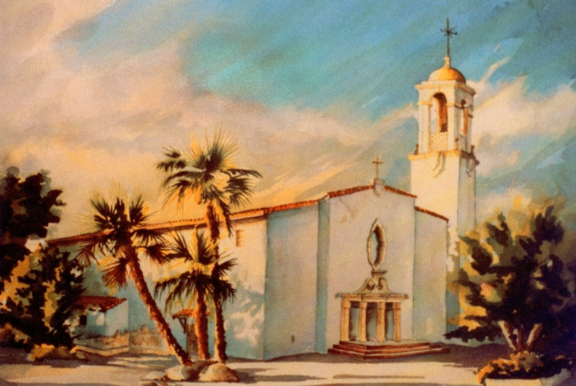
Preparing for Quinceañeras
at
St. Margaret Mary Church
12686 Central Ave
Chino, California 91710
(909) 591-7400
QUINCEAÑERAS
On behalf of St. Margaret Mary Church, hearty congratulations on your interest in celebrating a Quinceañera! The parish is happy to accompany and support you at this special time.
The Quinceañera is a special blessing, usually given around a young lady’s 15th birthday, which celebrates her passage from childhood to adolescence. We gather at the Church to give thanks to God for the gift of her life and ask that God watches over her in the years ahead.
You will want to begin planning this special occasion by setting up an initial appointment with Gabriela 6 months in advance.

PREPARATION
1. Contact the Parish Office (909-591-7400) to make an appointment with Gabriela Gilbert to begin the process. Also, if you are not already participating in the parish Confirmation Program or Youth Group, you should begin as soon as possible.
2. The Quinceañera can be celebrated at an individual separate Mass, or a blessing at one of our regular scheduled Masses. The Quinceañera can be celebrated with a single young lady or with many others celebrating birthdays.
3. After your initial contact with Gabriela Gilbert, you can give your offering to the Church and reserve your special date on our calendar.
4. The coordinator of our parish Quinceañera team will contact you --- Blanca Lindley (909) 952-8962. Blanca will help you begin the spiritual preparation our Church asks. When you have completed your classes, you will schedule a final meeting with Blanca to make arrangements for the ceremony itself --- including readings, appropriate symbols and rehearsal if you are having a separate individual Mass. This is done the week before your special day.
4. It is a very good idea for you, your padrinos, family and friends to prepare spiritually for Mass by sacramental confession. Normal confession times at St. Margaret Mary are Saturday from 7:30 to 8:30 am … or almost anytime by appointment.

MORE DETAILS!
• Only one professional photographer is allowed (No flash pictures are taken except during the entrance procession and during the recession at the end of the ceremony). No passing in front or along the center aisle during the ceremony, please.
• Videotaping is allowed, but without special lights or roll-around equipment, which may distract from prayer. No passing in front of or along the center aisle during the ceremony, please.
• For good order, we ask that there be no aisle runners; no objects (e.g. rice, confetti, birdseed) thrown in or around the church; and no changing of the basic church environment.
• We allow and encourage two (2) large bouquets of flowers, one at the altar and one at the ambo (pulpit). All flowers used in the sanctuary are left there as a thanksgiving offering to God.
• Pew bows or flowers should be secured to the pews with rubber bands, flower clips or covered floral wire only. No tape, please.

CUSTOMARY OFFERING
a) If you want an individual Mass and celebration in the church, the offering is - $500.00 which covers the cost of rehearsal and ceremony. This is paid 50% when you reserve your date and the other 50% a month before the ceremony.
b) If you want a simple Quinceañera blessing given at one of our regular community Masses, the offering is $50.00
c) You are welcome to give a stipend to the presiding priest if you like, but this is not expected or required.
d) Church offering should be made payable to St. Margaret Mary Church. All other checks (i.e. musicians) should be made payable to the specific individual.

*During part of the 2017/2018 year the church building may be involved in a renovation, during such time there may be construction in the church…… or the ceremony may be moved to the parish hall or Sacred Heart building.

Before I formed you in the womb I knew you,
Before you were born I dedicated you!
(Jeremiah 1:4)

