St. Margaret Mary’s confirmation program will use TEXT MESSAGES to send you important information about your child’s activities and events throughout the year. This is our main form of communication to our parents, so please ensure you sign up today. Every year you must sign up again, so If you have signed up in the past you will not get messages. You must sign up again based on the year your child is enrolled.

For Year 1 Parents | For Year 2 Parents | For Year 3 Parents
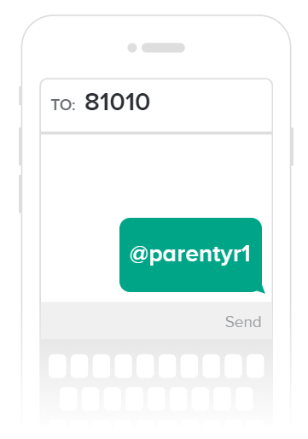 | 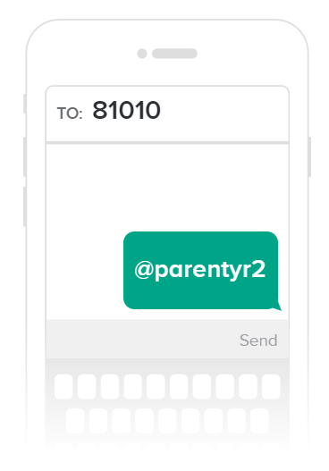 | 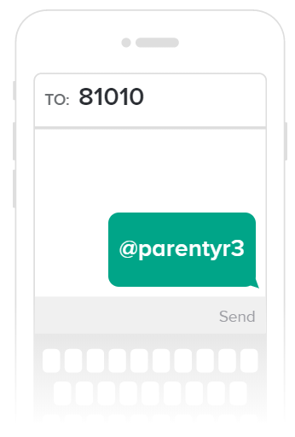

Instructions: Use your cell phone and type the phone number 81010. In the message area type the message above based on the year your student is enrolled in. Once you sign up you will receive a welcome text welcoming you to the confirmation program. If anyone has trouble with the number 81010, they can try texting to (909) 810-2900.

