ST. MARGARET MARY PARISH
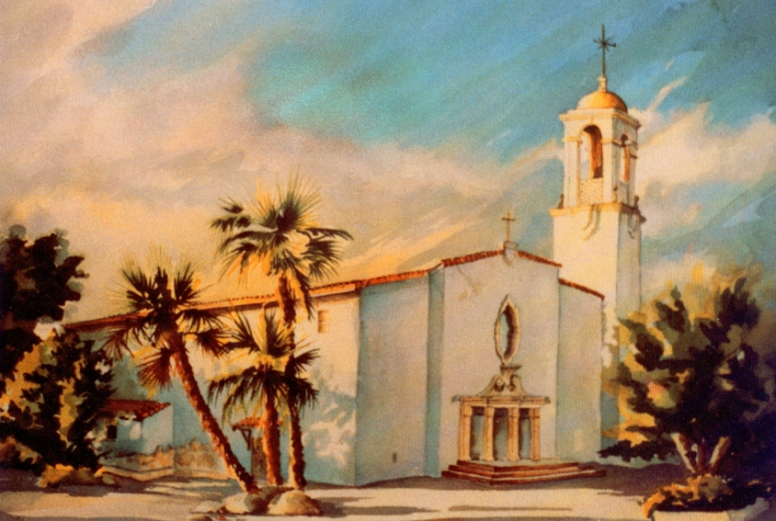
Preparing teens for the Sacrament of Confirmation
St. Margaret Mary Church
12686 Central Ave
Chino, California 91710
(909) 591-7400

And when he had said this, he breathed on them and said to them, “Receive the Holy Spirit. John 20:22

The Sacrament of Confirmation
Welcome! Your son or daughter is about to embark on the wonderful journey toward receiving the Sacrament of Confirmation. This is an exceptional time in a young person’s life. As they prepare for this sacrament they will be given an opportunity to grow as a young mature Catholic. They will also be sent on a mission, with God’s grace, to share their faith and love for God with others.
As a parent, we hope you embrace this journey as an opportunity for your whole family to grow in holiness and faith. I am often inspired by the faith of the teens and parents that choose this journey with such vigor, yet I also realize how the busyness of life can make this journey feel more like an obligation than an opportunity. Our hope is that you enter this process with expectant faith, knowing that an investment in God always yields positive results.
The Role of Parents / Sponsor
Parents play the most significant role in passing on the faith to their children. We have come to realize that the following requirements create the most rewarding Confirmation experience. Please notice that some of the requirements involve parents and/or godparents because of your great influence. If parents at this time in their lives are not attending Mass and are unable to attend mandatory days of prayer, it is important to carefully select a sponsor who can attend so that the young person has the support to complete the requirements for Confirmation.
Parent / Sponsor Requirements

- Parents and/or sponsor are asked to attend a spiritual one day retreat. Parents or sponsor are required to attend once during their teens overall participation in the Confirmation program. Please choose one of the following dates during your teens second year of Confirmation:

    - January 4th, 2020 from 9am to 2pm
    - January 18th, 2020 from 9am to 2pm
    - February 1st, 2020 from 9am to 2pm
    - February 29th, 2020 from 9am to 2pm (Spanish)

Candidate Participation in the Holy Mass
Mass and the Eucharist lie at the center of our youth ministry and Confirmation program. In fact, weekly attendance at Sunday Mass is one of the distinguishing characteristics of a practicing Catholic, yet we find many teens not attending Mass. So our Confirmation program implements in 2019-2020 a mandatory requirement for all teens to attend Mass twice per year with their Confirmation class. In addition, it is encouraged that a parent or sponsor also attend to help nurture the family and sponsor bond. Teens at Mass will serve in the following capacities:

Music Ministry Altar Server Ushering
Eucharistic Minister Lector Participant

Your support of this new initiative will help ensure that our young people find goodness and life within the Church’s greatest prayer, the Mass.
- At the beginning of the Confirmation season, each class will be assigned two Sundays they must attend Mass at 5:00pm. Parents and/or sponsor are invited to attend Mass with your teen, but as always regular attendance at Sunday Mass is highly encouraged.

Summary of Candidate Requirements

Also, as a reminder… here is a quick summary of the requirements of our Confirmation program for each year of participation. Our teen’s effort to complete these requirements displays their conscientiousness toward receiving the Sacrament of Confirmation and their desire to be followers of Jesus Christ:

Year 1 Candidate Requirements
- The candidate and parents are highly encouraged to attend Sunday Mass. It is mandatory for the teen to attend Mass twice a year when their Confirmation class is assigned to serve.
- Attend Confirmation class according to calendar.
(only two absences allowed per year)
- Complete five hours of service before end of Confirmation calendar.

More information about the requirements are available on our website at http://smmchino.org/confirmation/

Summary of Candidate Requirements Cont.

Year 2 Candidate Requirements

- The candidate and parents are highly encouraged to attend Sunday Mass. It is mandatory for the teen to attend Mass twice a year when their Confirmation class is assigned to serve.
- Attend Confirmation class according to calendar.
(only two absences allowed per year)
- Attend Confirmation weekend retreat on the weekend of December 13-15, 2019.
- Must have 15 hours of service complete before end of Confirmation calendar.
- Select and include a sponsor who should be active during the Confirmation process. Due by Nov. 2019
- Parent and/or Sponsor must attend one day of prayer. (Should be done during year 2)

More information about the requirements are available on our website at http://smmchino.org/confirmation/

Summary of Candidate Requirements Cont.

Year 3 Candidate Requirements

- The candidate and parents are highly encouraged to attend Sunday Mass. It is mandatory for the teen to attend Mass twice a year when their Confirmation class is assigned to serve.
- Attend Confirmation class according to calendar.
(only two absences allowed per year)
- Attend Confirmation weekend retreat March 6-8, 2020.
- Complete, in total, 20 hours of service by March 2020.
- Select a sponsor to help the candidate in preparation for reception of the Sacrament. Due Nov 2019
- Parents and/or Sponsor must attend one day of prayer if not attended during candidates second year of Confirmation.
- Candidate will select a saint that is a model of faith for their life.

More information about the requirements are available on our website at http://smmchino.org/confirmation/

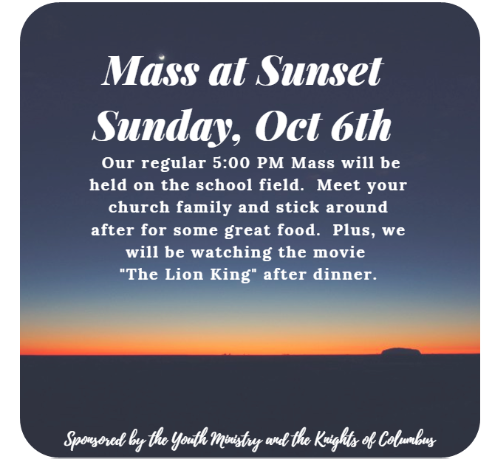

A New Season of Youth Ministry Events 2019

- Sept 29th – Bowling Night. We will meet at Chaparral 300 in Chino Hills from 6:30pm to 9:00pm. Cost is $12.
- Oct 6th - Mass at Sunset. Celebrate Mass on the field with great food.
- Oct 13th – Life Night. We will be discussing life’s purpose and how we can turn to God for help.
- Oct 20th – Praise Night. Join us in the hall for a moment of reflection and prayer.
- Oct 27th – Pumpkin Carving. Join us in the hall as we carve some pumpkins and prepare for Halloween.

